**User Guide for H.O.S.T Application (Android App)**

**Designed for Habitat for Humanity**

Cody Delorme, Ryan Vanek, Samuel Adams, Scott Klusaw

This manual is designed to assist the users of the Habitat Offline Survey Tool’s Android application. This will include initializing the application, using the application and interfacing the surveys with Microsoft Sharepoint.

Table of Contents

[Introduction 2](#_Toc353918520)

[Application Overview and Login 3](#_Toc353918521)

[Form Selection Screen 3](#_Toc353918522)

[Form Editing Screen 4](#_Toc353918523)

[Short Answer Questions 4](#_Toc353918524)

[Choice Questions 5](#_Toc353918525)

[Likert Scale Questions 6](#_Toc353918526)

[Using the Form Editing Screen 6](#_Toc353918527)

[Submit, Delete and Save Screen 7](#_Toc353918528)

[Frequently Asked Questions 8](#_Toc353918529)

# Introduction

This guide is intended for the non-administrator user of the H.O.S.T. Android App. The administrator information for the Android App is contained in the Admin Tool Guide. The purpose of the H.O.S.T. Android App has been created to allow the users to fill out forms which have been created by administrators or approved administrator users. After these forms have been completed, the completed forms are then able to be submitted to Microsoft SharePoint, and the information will be added to the database.

# C:\Users\Scott\Desktop\Screenshot_2013-04-14-19-58-02.pngApplication Overview and Login

Before using the Android App, be sure that an administrator has done the first time configuration. To begin the startup of the Android App, press your finger on the H.O.S.T. Android App on the device’s touch screen. As illustrated on the right.

## Form Selection Screen

When the user first opens the HOST Android program, they will immediately be shown the “Template Group Selection” Screen. At this point, the user should attempt to sign in to the HOST Android Application using their first name. They do not need a username or password, but rather this will collect the name of the person filling out the form if it needs to be collected later.

To Sign in. Start by pressing the Sign in button at the top of the Form Selection Screen. This will open a pop up where the user can input their name.

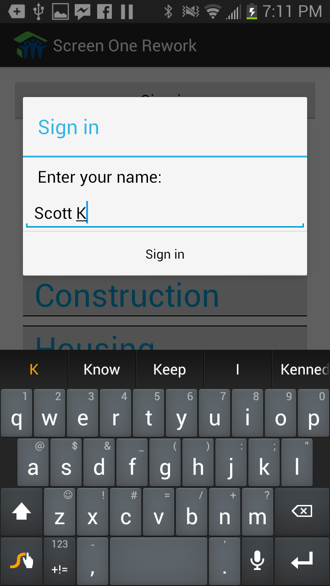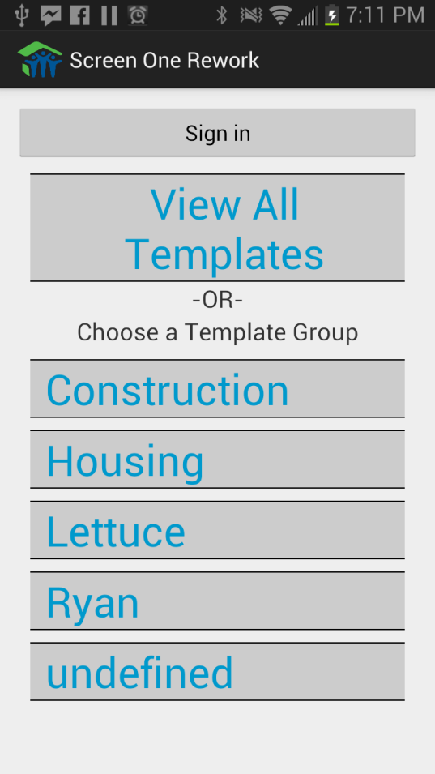 After the user has been logged in, they may begin filling out forms using the device. If the user no longer needs to use the device, or needs to hand the device over to another user, they may log out using the “Log out” button or change their name using the “Change” button.

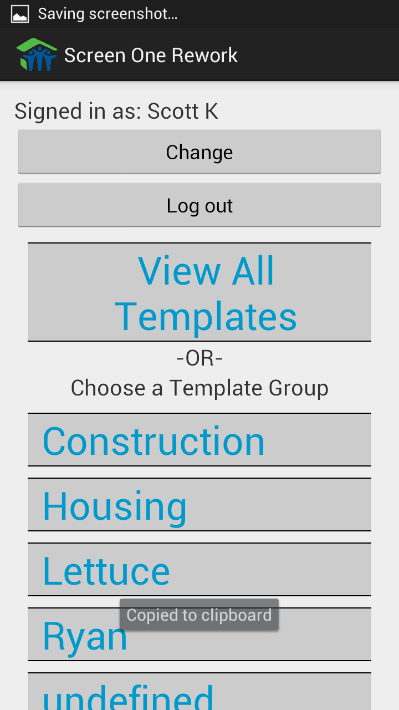 In order to begin answering questions to a form, or edit a form that has already been created, we must dig down to that form’s template. We can find the template by choosing one of the options listed at the Template Group screen. Form templates are associated in groups much like how departments are associated within companies. All of the forms related to Construction are located in the Construction form Template Group, and likewise for Housing. This can make finding a form easier if there are many different groups using the HOST Android App. If you do not know what group is associated with the form that needs to be filled out, pressing View All Templates will show all Templates associated to all groups, allowing the user to find the form they want.

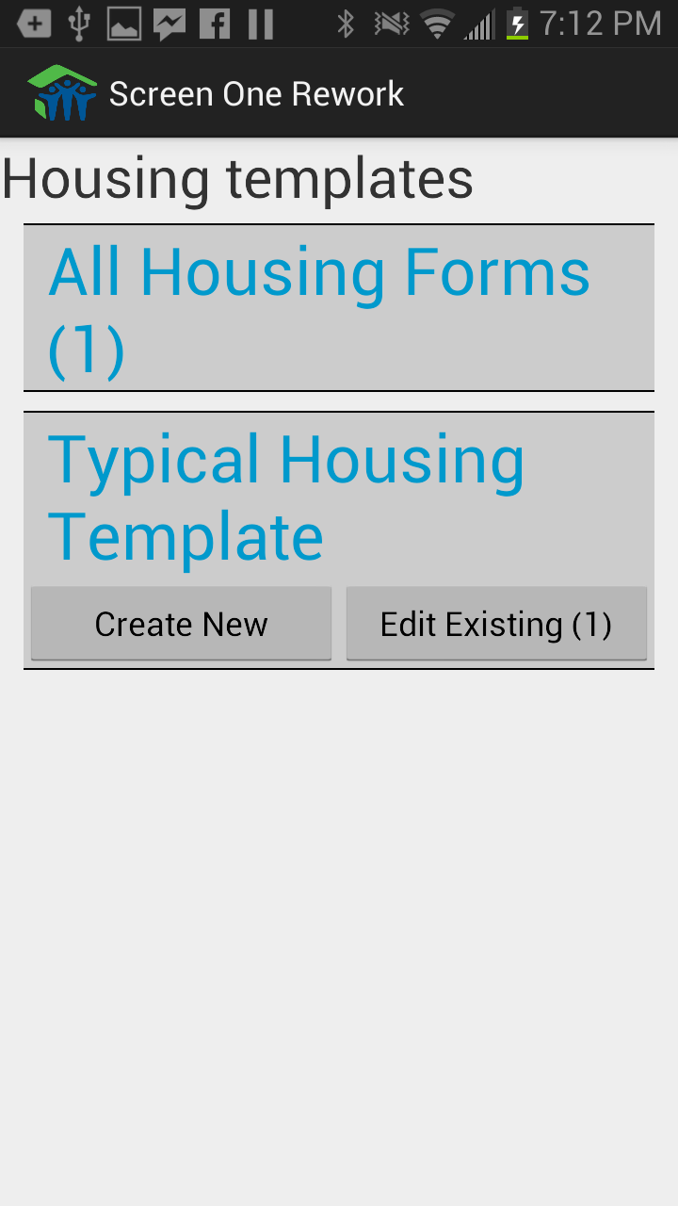

After choosing the group type, or choosing to look at all of the group’s templates, all of the templates will be shown on a screen similar to the right. Here we can see the option to create a new form based on the “Typical Housing Template” or to edit an existing Typical Housing Template that already exists. If we wanted to view all of the created forms for the type of Housing, so they can be edited, we could also click on the All Housing Forms option.

Clicking on the Create New option will create a new form based on that template, and will direct the user to the Form Editing Screen. Refer to the section on the Form Editing Screen for more information.

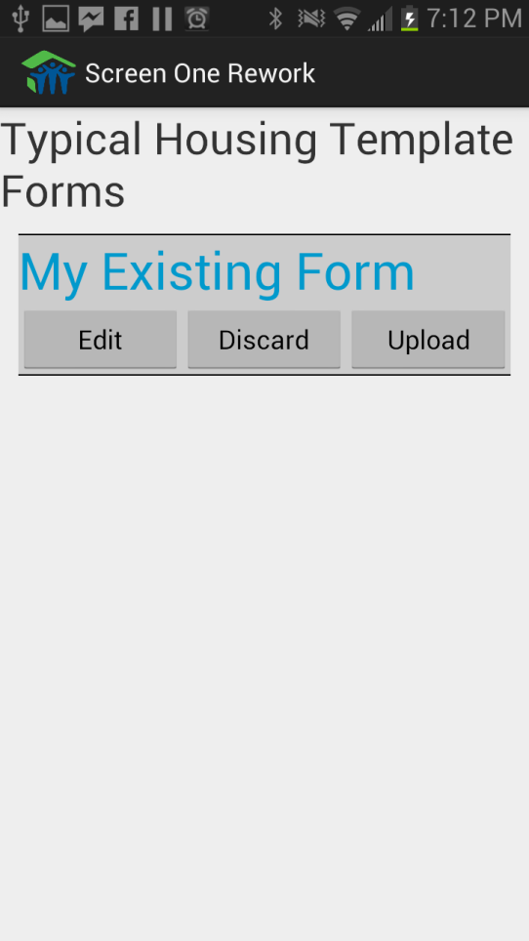However if the user chooses to edit an existing form, based on one or many different types of forms on the Template Selection screen, they will be moved to the Existing forms screen. Here the user can view the existing forms that are on the device based on the parameters they specified. From here they may choose edit to move to the Form Editing Screen. For more information regarding the Form Editing screen, refer to the Form Editing Screen section.

The user may also choose to discard the existing form to remove the data from the device permanently, or choose upload to send the information to the SharePoint database, and have the data removed from the device. These buttons function similarly to the discard and upload buttons that exist on the Submit, Delete and Save screen. For more information, refer to the Submit, Delete and Save screen section.

## Form Editing Screen

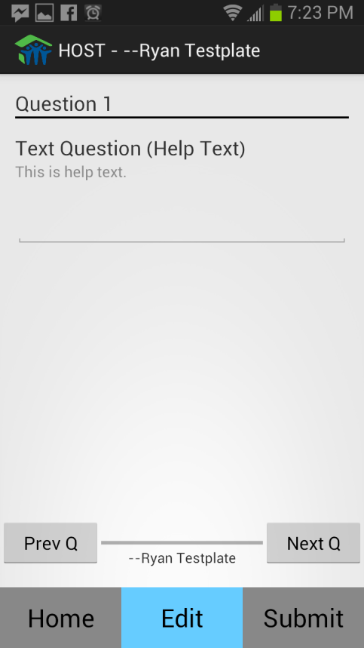 When the user reaches the Form Editing Screen, they have successfully created a new form, or began editing an already existing form. The way that this screen will look will vary based on what sort of question is being asked. There are only three types of questions in the Application: Short Text Answer Questions, Single and Multiple Choice Questions, and Likert Scale Questions.

### Short Answer Questions

First type of question is a Short Text Answer. To answer this type of question, simply tap on the provided space for an answer, and type in a response using the android keyboard.

Some short answer questions require a date, and will supply a calendar spinner instead of a keyboard.

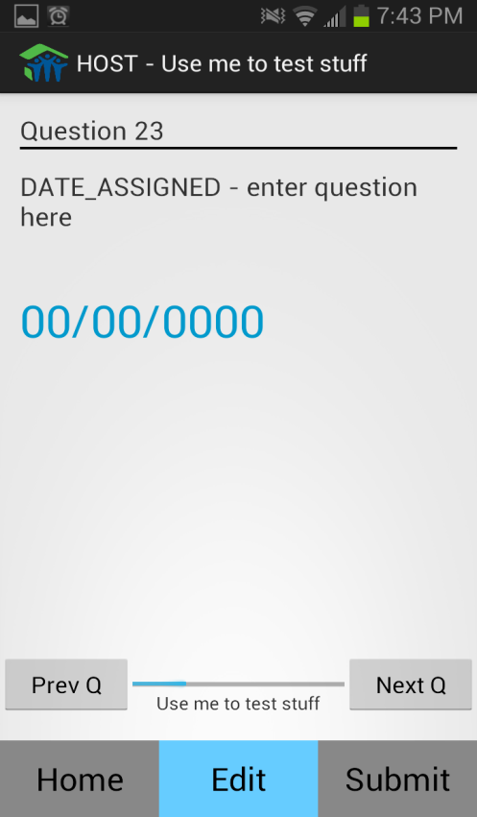 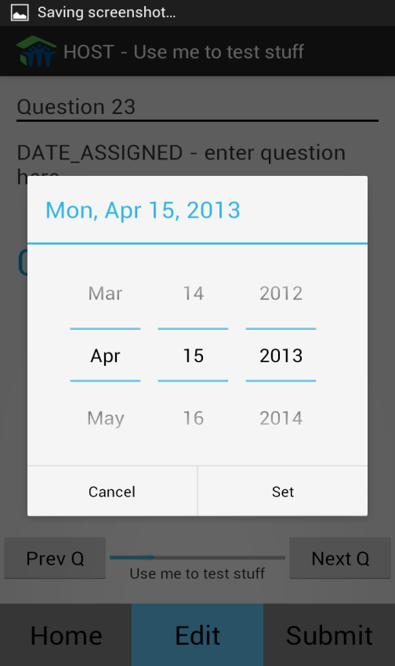

### Choice Questions

The second type of question is a Single or Multiple choice questions. These two questions are associated together because they are answered similarly. For single choice questions, only one choice can be chosen per question, and is shown by circular check boxes. For multiple choice questions, multiple choices can be chosen per question, and is shown by square check boxes.

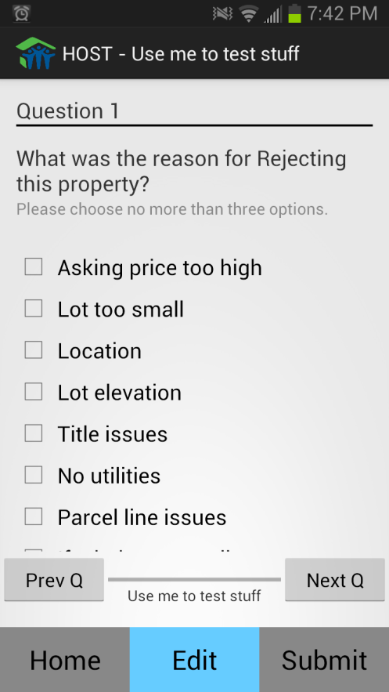 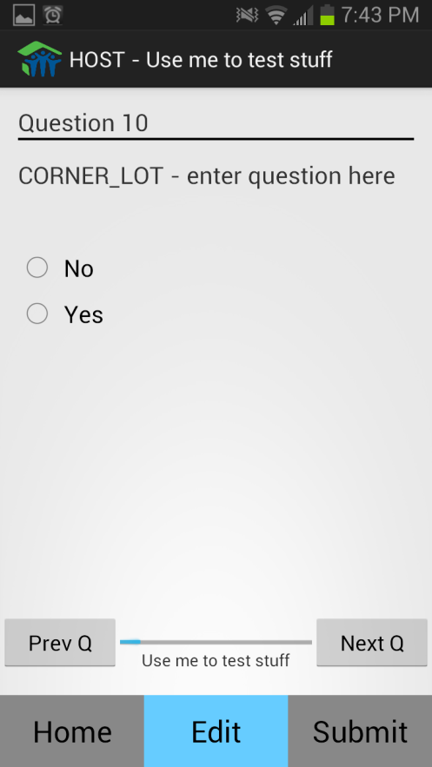

These questions can also have a choice of “Other”. If “Other” is one of the selected choices for a question, a small text box will appear next to it, to provide details about the choice.

### Likert Scale Questions

Last type of question is the Likert Scale questions, or more informally, Rating Questions. These questions are similar to Single choice questions, but the possible answers are on a scale. To answer this type of question, simply select the choice that closest resembles your personal answer.

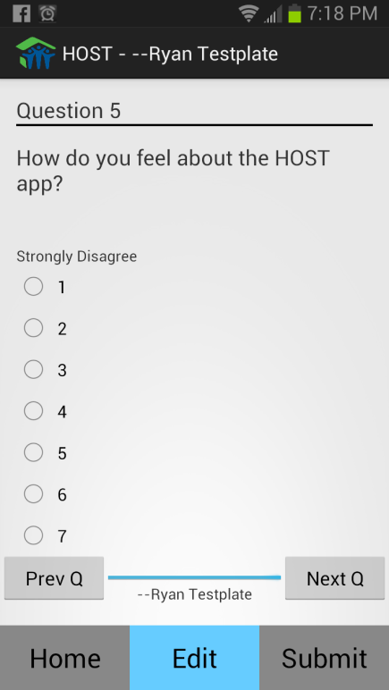

### Using the Form Editing Screen

To change question in the Android App, simply swipe left on the device to move to the next question and swipe to the right to move to the previous question. To maintain a sense of place within the form, the question number is added on the top of the screen, and a progress bar is given at the bottom of the screen.

After each question is answered, the App will automatically save your answers in case of an accident. When the form is completed to the best of the user’s ability, the auto-save will ensure that the form is saved on the device, and the user can choose to return to the Form Selection menu to fill out more forms by pressing the home button, or to move to the Submit and Delete screen by pressing the Submit button.

## C:\Users\Scott\Desktop\Screenshot_2013-04-14-17-53-30.pngSubmit, Delete and Save Screen

When the user reaches the final screen for the Android App, they have the choice of uploading the current form they have selected by pressing the Upload button.

To ensure that all answers have been filled out completely, the Edit button may be pressed to view the form’s answers one last time. If a form is successfully uploaded, it will be permanently removed from the Android device.

After pressing the Upload button, a pop up notification will display, confirming if the user wishes to upload the form now. After pressing “Upload” on the pop-up to confirm that the form is ready to be uploaded, the form will be sent to Microsoft SharePoint and will be removed from the device.

If the user simply wants to save the new form to upload later, the user may press the save button, and press the Home button to return to the Form Selection Screen. However, the Android App will auto-save after each completed question, so it is unnecessary to press the save button again.

If the user has decided that the current form needs to be deleted, then the Discard button may be pressed to begin the form deletion process.

After the user presses Delete, a pop-up will display confirming if the form is meant to be deleted. If the user is unsure, they may choose to still Keep the form. Otherwise, they may choose Discard and remove the form permanently from the device.

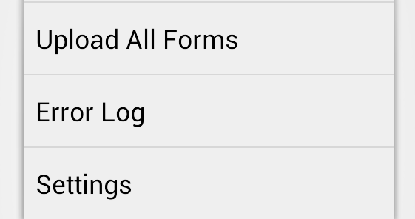By pressing the menu button at this screen, the user also has the option to upload all forms currently saved to the device by pressing the “Upload All Forms” option. This feature will only work when the device is connected to Wi-Fi, and be sure to ask if the forms are ready for upload.

# Frequently Asked Questions